1. Make sure that docker and docker-compose are installed.

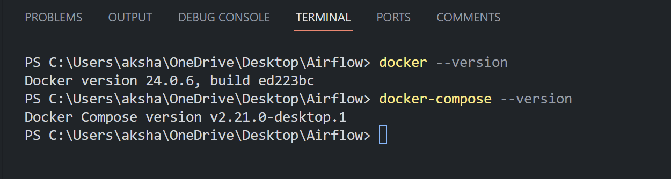

1. Install the docker-compose.yaml file by running this command.

**curl** 'https://airflow.apache.org/docs/apache-airflow/2.8.3/docker-compose.yaml' -o 'docker-compose.yaml'

1. Create a new file called .env and enter these lines:

AIRFLOW_IMAGE_NAME = apache/airflow:2.8.3  
AIRFLOW_UID = 50000

1. Run this command

**Docker-compose up airflow-init**

1. Run this command. This will create three folders: dags, logs, and configs

**docker-compose up -d**

1. Run this command to check whether all the services are running or not

**Docker ps**

1. The Airflow webserver will be running at this address: <http://localhost:8080/home> The username and password both are airflow
2. To stop the airflow services, run this command

**Docker-compose down**